ANSWERS

ANSWER-A

Intelligent Agent – Warehouse Robot
A warehouse robot is an intelligent agent that moves around a warehouse, identifies products, picks and places items, and delivers them to the required location.

PEAS Description
PEAS | Description
P – Performance Measure | Correctly picking and delivering products, minimum time, minimum errors, avoiding collisions, and saving energy.
E – Environment | Warehouse, shelves, products, workers, other robots, obstacles, pathways, loading/unloading areas.
A – Actuators | Wheels/motors for movement, robotic arm for picking and placing products, gripper, and lifting mechanism.
S – Sensors | Camera, distance/proximity sensors, barcode/RFID scanner, GPS/position sensors, and obstacle sensors.

Formal Representation
Agent: Warehouse Robot
Task: Pick products → Navigate → Deliver products → Return/Continue next task.
PEAS = (Performance, Environment, Actuators, Sensors)

___________________________________________________________________________

ANSWER-B

Type of Intelligent Agent for Warehouse Robot
The Utility-Based Agent is best suited for a warehouse robot.
A warehouse robot has to perform many tasks such as finding products, moving through the warehouse, avoiding obstacles, picking products, and delivering them to the correct location. A utility-based agent can compare different possible actions and choose the one that gives the best overall result.

Why Utility-Based Agent?
The robot can consider:
- Shortest route to the destination
- Safety from obstacles and workers
- Time required to complete the task
- Battery consumption
- Delivery accuracy
For example, if there are two routes, the robot can select a slightly longer route if it is much safer. Therefore, a utility-based agent is more suitable than a simple reflex or goal-based agent.

Simple Python Program
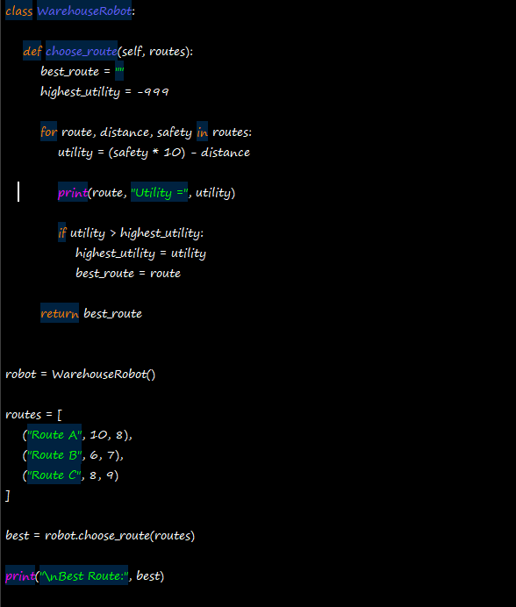
OUTPUT:
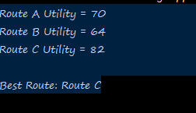

ANSWER-3

Formal Search Problem – Warehouse Robot
The warehouse robot can be modeled as a search problem where the robot must find a path from its starting position to the location where a product must be delivered.

1. Initial State
The robot starts at a particular location in the warehouse with the required product.
Example:
Initial State = Robot at (0,0), Product picked

2. Goal State
The goal is to reach the required delivery location with the product.
Example:
Goal State = Robot at (4,4), Product delivered

3. Actions
The robot can perform the following actions:
- Move Up
- Move Down
- Move Left
- Move Right

4. Transition Model
The transition model describes how the warehouse robot's position changes after an action.
For example:
- Move Up → (x, y+1)
- Move Down → (x, y-1)
- Move Left → (x-1, y)
- Move Right → (x+1, y)
The robot cannot move outside the warehouse or through obstacles.

5. Path Cost Function
The path cost is the total cost of all movements.
For simplicity:
Cost of each movement = 1
Therefore:
Path Cost = Number of movements
The robot should find a path with the minimum cost.
Simple Python Program
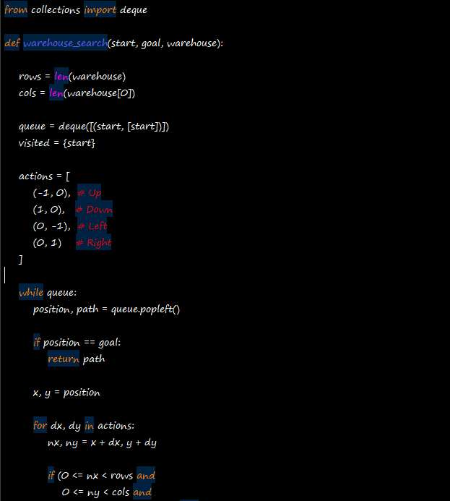

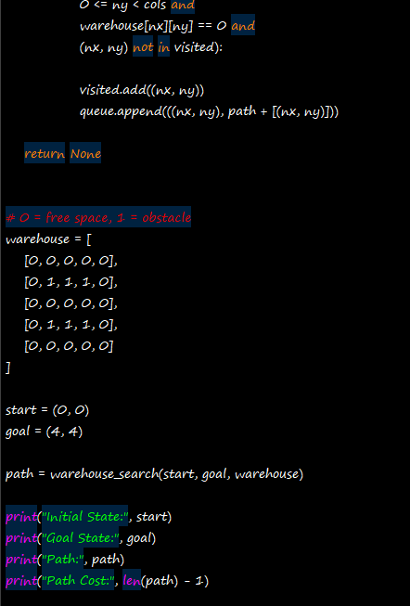
OUTPUT:
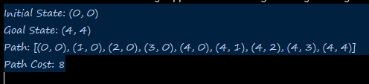

ANSWER-D

Breadth-First Search (BFS)
BFS explores the nodes level by level using a FIFO queue.

Step-by-Step Expansion
Step | Expanded Node | Frontier / Queue
1 | (1,1) | (1,2), (2,1)
2 | (1,2) | (2,1), (1,3), (2,2)
3 | (2,1) | (1,3), (2,2), (3,1)
4 | (1,3) | (2,2), (3,1), (1,4), (2,3)
5 | (2,2) | (3,1), (1,4), (2,3), (3,2)
6 | (3,1) | (1,4), (2,3), (3,2), (4,1)
7 | (1,4) | (2,3), (3,2), (4,1), (1,5), (2,4)
8 | (2,3) | (3,2), (4,1), (1,5), (2,4), (3,3)
9 | (3,2) | (4,1), (1,5), (2,4), (3,3), (4,2)
10 | (4,1) | (1,5), (2,4), (3,3), (4,2), (5,1)
11 | (1,5) | (2,4), (3,3), (4,2), (5,1), (2,5)
12 | (2,4) | (3,3), (4,2), (5,1), (2,5), (3,4)
13 | (3,3) | (4,2), (5,1), (2,5), (3,4), (4,3)
14 | (4,2) | (5,1), (2,5), (3,4), (4,3), (5,2)
15 | (5,1) | (2,5), (3,4), (4,3), (5,2)
16 | (2,5) | (3,4), (4,3), (5,2), (3,5)
17 | (3,4) | (4,3), (5,2), (3,5), (4,4)
18 | (4,3) | (5,2), (3,5), (4,4), (5,3)
19 | (5,2) | (3,5), (4,4), (5,3)
20 | (3,5) | (4,4), (5,3), (4,5)
21 | (4,4) | (5,3), (4,5), (5,4)
22 | (5,3) | (4,5), (5,4)
23 | (4,5) | (5,4), (5,5)
24 | (5,4) | (5,5)
25 | (5,5) Goal | Empty

Final Path
(1,1) → (1,2) → (1,3) → (1,4) → (1,5) → (2,5) → (3,5) → (4,5) → (5,5)

Total Cost
Each movement has a cost of 1.
Total Cost = 8

Result
BFS successfully finds the shortest path from (1,1) to (5,5) with a total path cost of 8.

SIMPLE PROGRAM: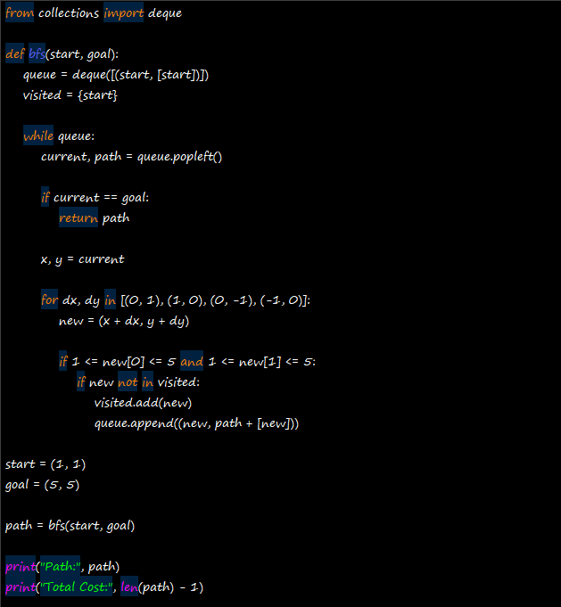
OUTPUT:
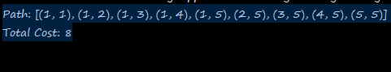

ANSWER-E

Depth-First Search (DFS)
Initial State: (1,1)
Goal State: (5,5)
Movement: Up, Down, Left, Right
Cost of each movement: 1
Using DFS with the order Right → Down → Left → Up, the robot explores one path deeply before backtracking.

Step-by-Step Stack
Step | Expanded Node | Stack
1 | (1,1) | (1,2), (2,1)
2 | (1,2) | (1,3), (2,2), (2,1)
3 | (1,3) | (1,4), (2,3), (2,2), (2,1)
4 | (1,4) | (1,5), (2,4), (2,3), (2,2), (2,1)
5 | (1,5) | (2,5), (2,4), (2,3), (2,2), (2,1)
6 | (2,5) | (3,5), (2,4), (2,3), (2,2), (2,1)
7 | (3,5) | (4,5), (3,4), (2,4), (2,3), (2,2), (2,1)
8 | (4,5) | (5,5), (4,4), (3,4), (2,4), (2,3), (2,2), (2,1)
9 | (5,5) | Goal reached

Final Path
(1,1) → (1,2) → (1,3) → (1,4) → (1,5) → (2,5) → (3,5) → (4,5) → (5,5)

Total Cost
Number of movements = 8
Total Path Cost = 8

Simple Python Program:
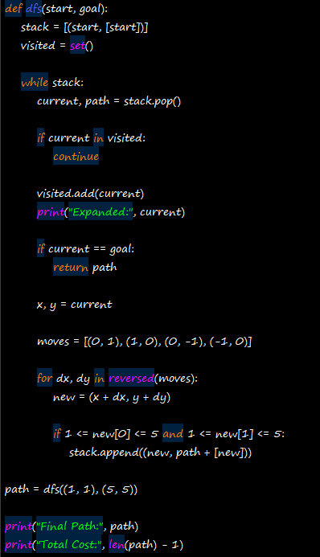
OUTPUT
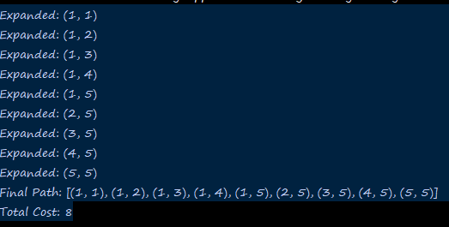

Conclusion
The warehouse robot was successfully modeled as an intelligent agent using the PEAS framework. A utility-based agent was selected because it can choose the safest and most efficient actions. The warehouse task was then represented as a search problem using the initial state, goal state, actions, transition model, and path cost.
BFS found the shortest path from (1,1) to (5,5) with a cost of 8, while DFS also reached the goal with a cost of 8 for the given movement order. Thus, search algorithms can help the warehouse robot navigate efficiently from its starting location to the required destination.

______________________________________________________________________________________________________________________________________________________

